Bangladesh Medical Association (BMA)
List of Life Member-46
45. BMA Narsingdi Branch

Sl No | Voter No | Voter Details
1 | Voter No  LM-4500001  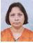 | DR. BITHIKA ROY  F/Name: Late Ashutosh Roy  M/Name:  BM & DC Reg. No:  NID:  Cell:  Address: Mallik X-Ray Clinic  19, Sadar Road  Narsingdi  Blood Group:
2 | Voter No  LM-4500002  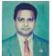 | DR. RATAN KUMAR MALLIK  F/Name: Mr.jatindra Kumar Mallik  M/Name:  BM & DC Reg. No:  NID:  Cell:  Address: Mallik X-Ray Clinic,  19, Sadar Road  Narsingdi  Blood Group:
3 | Voter No  LM-4500003  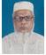 | DR. MD. RAFIQUL HAQUE  F/Name: Dr. Abdul Malek  M/Name:  BM & DC Reg. No:  NID:  Cell:  Address: Patpotty, Narsing Bazar  Narsingdi  Blood Group:
4 | Voter No  LM-4500004  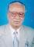 | DR. MD. SEARAZUL ISLAM  F/Name: Late Alhaz Abdul Mazid  M/Name:  BM & DC Reg. No:  NID:  Cell:  Address: Mita Nursing Home  Sadar Road  Narsingdi  Blood Group:
5 | Voter No  LM-4500005  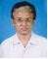 | DR. A.T.M GOLAM DASTOGIR  F/Name: Late Md. Nurul Haque  M/Name:  BM & DC Reg. No:  NID:  Cell:  Address: The Chambers Path Lab  C & B Road  Narsingdi  Blood Group:
6 | Voter No  LM-4500006 | DR. MD. SUHRAWARDY  F/Name: Late Md. Akram Ali  M/Name:  BM & DC Reg. No:  NID:  Cell:  Address: Radiologist  Sadar Hospital  Narsingdi  Blood Group:
7 | Voter No  LM-4500007  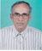 | DR. MURARI MOHAN BISWAS  F/Name: Late Hor-chandra Biswas  M/Name:  BM & DC Reg. No:  NID:  Cell:  Address: 241, Brahhondi  P.O. Narsingdi College Road  Narsingdi  Blood Group:
8 | Voter No  LM-4500008  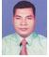 | DR. NABA KUMAR DEBNATH  F/Name: Rabindra Chandra Debnath  M/Name:  BM & DC Reg. No:  NID:  Cell:  Address: Palash Villa. Vill. Ghorashal  P.O. Ghorashal, P.S- Palash  Narsingdi  Blood Group:
9 | Voter No  LM-4500009  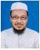 | DR. A.H. M YUSUF BHUIYAN  F/Name: Late Abdur Rahman Bhuiyan  M/Name:  BM & DC Reg. No:  NID:  Cell:  Address: Niramoy Medical Centre  Narsingdi  Blood Group:
10 | Voter No  LM-4500010  No Image | DR. MD. JAMAL UDDIN BHUIYA  F/Name: Late Md. Sultan Uddin Bhuiya  M/Name:  BM & DC Reg. No:  NID:  Cell:  Address: Kawria Para  Narsingdi  Blood Group:
11 | Voter No  LM-4500011  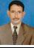 | DR. M.S.S HASAN ALZAMI  F/Name: Late Md. Waliullah  M/Name:  BM & DC Reg. No:  NID:  Cell:  Address: Sarak Brahmandi  P.O. Narsingdi College Road  Narsingdi  Blood Group:
12 | Voter No  LM-4500012  No Image | DR. MD. GULAM KIBRIA  F/Name:  M/Name:  BM & DC Reg. No:  NID:  Cell:  Address: T.F. Narayengonj LM-4400065  Next  Trasfered to Dhaka City. LM-1402847  Blood Group:  TRANSFERED to BMA Dhaka City  LM-1405543
13 | Voter No  LM-4500013  No Image | DR. MD. ABUL KASHEM  F/Name: Md. Abu Sayeed Bhuiyan  M/Name:  BM & DC Reg. No: 22827  NID:  Cell:  Address: Flat-B-12, Gaoshia Dinesty,  109/1, Kakrail Road, Dhaka-1000.  Blood Group:
14 | Voter No  LM-4500014  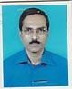 | DR. MD. ABDUL KHALEQUE TALUKDER  F/Name:  M/Name:  BM & DC Reg. No:  NID:  Cell:  Address: a  Blood Group:
15 | Voter No  LM-4500015  No Image | DR. MD. ABU ZAFAR  F/Name:  M/Name:  BM & DC Reg. No:  NID:  Cell:  Address: Chief Consultant,Progasive Lions Eye Hospital  Narsingdi  Blood Group:
16 | Voter No  LM-4500016  No Image | DR. MD. MONSUR ALI  F/Name:  M/Name:  BM & DC Reg. No:  NID:  Cell:  Address: Civil Surgeon  Narsingdi.  Blood Group:
17 | Voter No  LM-4500017  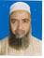 | DR. OBAIDUL BARI  F/Name: Late Md. Idris Ali  M/Name:  BM & DC Reg. No:  NID:  Cell:  Address: Master Super House  Birampur, Madhabdi  Narsingdi.  Blood Group:
18 | Voter No  LM-4500018  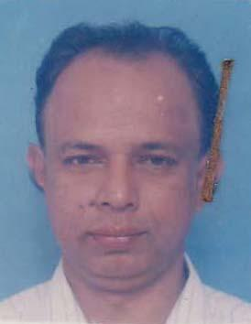 | DR. ABDUS SALAM ARIF  F/Name: M.a. Salam  M/Name: Iraki Begum  BM & DC Reg. No: 11493  NID: 2691649461944  Cell: 01713006864  Address: Flat # 4a, House # 10, Road # 15, Dhanmodi, Dhaka 1209.  Blood Group:
19 | Voter No  LM-4500019  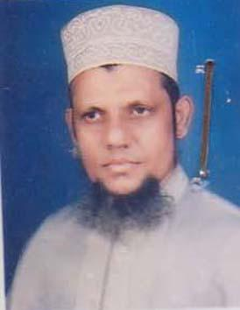 | DR. MINHAJ UDDIN AHMAD  F/Name: Late Mosleh Uddin Ahmad  M/Name: Begum Shamsun Nahar  BM & DC Reg. No: 16164  NID: 6826002612797  Cell: 01195140646  Address: Atandrila Bhavan, 98/1, Chhota Gadair Char (South), P.O; Madhabdi, Narshingdi.  Blood Group: O+
20 | Voter No  LM-4500020  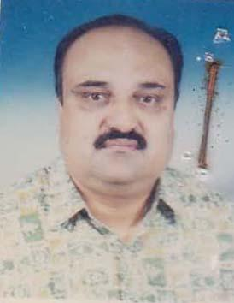 | DR. MANASH RANJAN CHAKRABORTY  F/Name: Tarapada Chakraborty  M/Name: Basanti Chakraborty  BM & DC Reg. No: 17349  NID: 2691649121478  Cell: 01713006863  Address: Ekanta, Flat No: 2/B, Road No: 8/A, House No: 322, Dhanmondi R/A, Dhaka 1209.  Blood Group: O+
21 | Voter No  LM-4500021  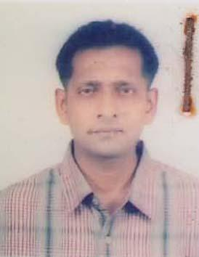 | DR. MD. MOZAMMAL HOQ  F/Name: Late Md. Aminul Hoq  M/Name: Hosne Ara Begum  BM & DC Reg. No: 16447  NID: 6826012658196  Cell: 01552307475  Address: House No: 179, West Brammondi, Narsingdi 1602.  Blood Group: O+
22 | Voter No  LM-4500022  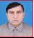 | DR. MD. BADIUL ALAM AKHAND  F/Name: Md. Ashkar Ali Akhand  M/Name:  BM & DC Reg. No:  NID:  Cell:  Address: Asstt. Surgeon  Vill : Chandan Bari, Upazila : Monohardi  Narsingdi  Blood Group:
23 | Voter No  LM-4500023  No Image | DR. MD. SHAHADAT HOSSAIN  F/Name: Momtaz Uddin Ahmed  M/Name:  BM & DC Reg. No:  NID:  Cell:  Address: Monahardi, Narsingdi.  Blood Group:
24 | Voter No  LM-4500024  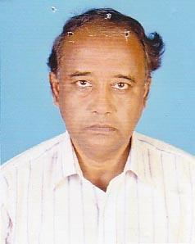 | DR. MD. ABDUR RAHSID  F/Name: Late Md. Shamsul Huda  M/Name:  BM & DC Reg. No:  NID:  Cell:  Address: Civil Surgeon,  Narsingdi.  Blood Group:
25 | Voter No  LM-4500025  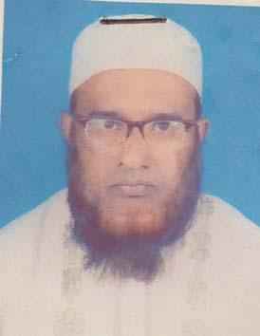 | DR. MD. ABDULLAH AL BAKI  F/Name: Late Dr. Mir Kashem Khan  M/Name: Late Sadmeher Khatun  BM & DC Reg. No: 17534  NID: 6826016688120  Cell: 01823034634  Address: 227/2 Satin Para, Narsingdi, Dhaka-1600.  Blood Group: B+
26 | Voter No  LM-4500026  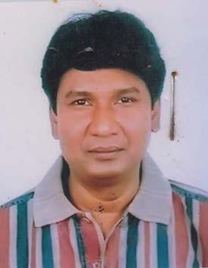 | DR. S.M. EHTESHAMUL HAQUE  F/Name: S.m. Shamsul Haque  M/Name: Mrs. Jobeda Begum  BM & DC Reg. No: 23323  NID: 2695045904950  Cell: 01715153457  Address: Prime General Hospital, Velanagar , Narshingdi  Blood Group: B+
27 | Voter No  LM-4500027  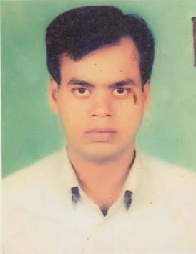 | DR. MD. SHAJEDUL HAQUE  F/Name: Md. Shamsul Haque  M/Name: Piara Begum  BM & DC Reg. No: 27368  NID: 6826012558607  Cell: 01711434108  Address: Vill & Post: Hairmara, P.S: Raipura, Dist: Narsingdi.  Blood Group: A+
28 | Voter No  LM-4500028  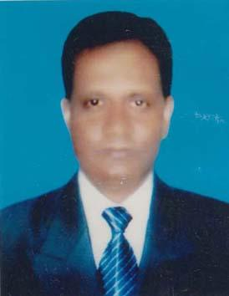 | DR. ANWARUL ASRAF KHAN  F/Name: Late Ashraf Uddin Khan  M/Name: Amena Begum  BM & DC Reg. No: 11728  NID: 6826301101480  Cell: 01724717966  Address: Purba Polash, Dorihaolapara Polash, Narsingdi.  Blood Group: A+
29 | Voter No  LM-4500029  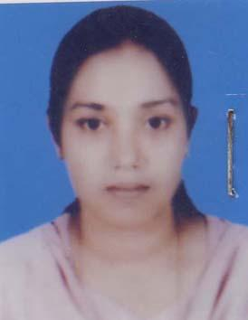 | DR. SHELLEY RANI DAM  F/Name: Benoy Bhusan Dam  M/Name: Shefali Rani Dam  BM & DC Reg. No: 24987  NID: 6826012656358  Cell: 01715139380  Address: EMO, 100 Bedded District Hospital Narsingdi.  Blood Group: O+
30 | Voter No  LM-4500030  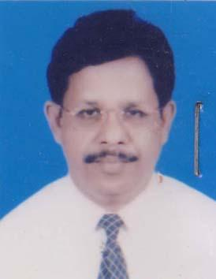 | DR. ASHIM KUMAR BHOWMICK  F/Name: Late Bhairab Chandra Bhowmick  M/Name: Late Aruna Rani Bhowmick  BM & DC Reg. No: 19205  NID: 6826012656359  Cell: 01711562210  Address: Medical Officer Clinic, Mother& Child Welfara Centre, Narsingdi.  Blood Group: O+
31 | Voter No  LM-4500031  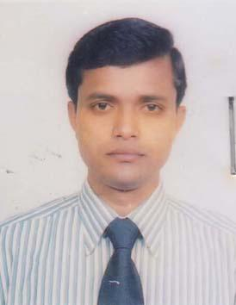 | DR. MOHAMMAD MAHMUDUL KABIR BASHER  F/Name: M.a Basher  M/Name: Salina Basher  BM & DC Reg. No: 39607  NID: 6826014665683  Cell: 01711276852  Address: 77, Middle Kanda Para, Narsingdi 1600.  Blood Group: O+
32 | Voter No  LM-4500032  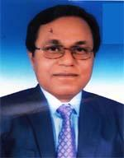 | DR. SUBINOY KRISNA PAUL  F/Name: Sukhamoy Paul  M/Name: Gauri Rani Paul  BM & DC Reg. No: 23039  NID: 19686826016688324  Cell: 01711-138034  Address: 78/1, Satir Para; Narsingdi  Blood Group: A-
33 | Voter No  LM-4500033  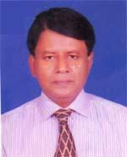 | DR. MD. SHAFIQUL ISLAM  F/Name: Hassen Ali  M/Name: Achhia Khatun  BM & DC Reg. No: 15244  NID: 2693624773947  Cell: 01817518688  Address: vill: dilarpur, PO: Nazarpur, Thana: Narshingdi, Zilla: Narshingdi  Blood Group: O+
34 | Voter No  LM-4500034  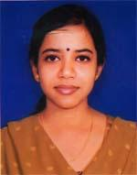 | DR. APARNA BISWAS  F/Name: Amar Kumar Biswas  M/Name: Manju Bhoje  BM & DC Reg. No: 61845  NID: 6816315191508  Cell: 01761971733  Address: MD. BANGLAQ, UFFL R/A, UFFL, GHORASHAL, PALASH, NARSHINGDI  Blood Group: B+
35 | Voter No  LM-4500035  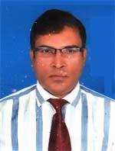 | DR. SYED MD. SAJJAD JALAL  F/Name: Late Syed Md. Nazimuddin  M/Name: Mrs. Amina Begum  BM & DC Reg. No: 29822  NID:  Cell: 01716401412  Address: 309 Satirpara, Narshingdi  Blood Group: B+
36 | Voter No  LM-4500036  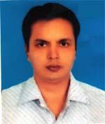 | DR. MOHSIN UDDIN AHMED  F/Name: Md. Liakot Ali  M/Name: Begum Zobida Khatun  BM & DC Reg. No: 27033  NID: 6861029806890  Cell: 01711174157  Address: Sadar Hospital, Narsingdi, Dist: Narsingdi  Blood Group:
37 | Voter No  LM-4500037  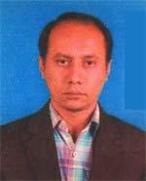 | DR. A.Q.M MOBIN  F/Name: Mohammad Abdur Razzaque  M/Name: Mrs. Jamila Khatun  BM & DC Reg. No: 37417  NID:  Cell: 01711314728  Address: 224, WEST KANDAPARA, NARSHINGDI SADAR, NARSHINGDI  Blood Group: B+
38 | Voter No  LM-4500038  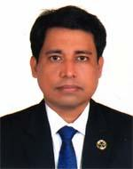 | DR. A.N.M MIZANUR RAHMAN  F/Name: Mohammad Mostafa Kamal  M/Name: Zahanara Begum  BM & DC Reg. No: 30992  NID: 19742698875745738  Cell: 01715025772  Address: 100 BEDDED DISTRICT HOSPITAL NARSINGDI  Blood Group: B+
39 | Voter No  LM-4500039  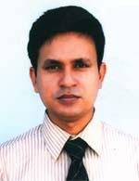 | DR. MOHAMMAD BHUIYAN ABDUS SAMAD AZAD  F/Name: Mohammad Dabir Uddin Bhuiyan  M/Name: Sahera Khatun  BM & DC Reg. No: 31922  NID: 6826011655249  Cell: 01711359292  Address: 100 Bedded District Hospital, Narsingdi  Blood Group: O+
40 | Voter No  LM-4500040  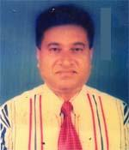 | DR. MD. KHURSHID ALAM  F/Name: Late. Abdul Khaleque Mia  M/Name: Ayesha Khatun  BM & DC Reg. No: 19886  NID: 2699501925950  Cell: 01790145729  Address: DOCTOR'S THE CHAMBER, C&B ROAD NARSINGDI.  Blood Group: O+
41 | Voter No  LM-4500041  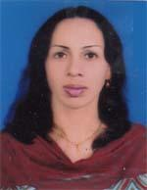 | DR. TAJIA ISLAM  F/Name: Dr. Serajul Islam  M/Name: Mrs. Rezia Islam  BM & DC Reg. No: 43113  NID: 6826014665682  Cell: 01672462662  Address: 77, Middle kanda para, Narshingdi  Blood Group: A+
42 | Voter No  LM-4500042  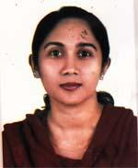 | DR. TAJREAN AKTER  F/Name: Alhaj Abdul Barik Miah  M/Name: Mrs. Firoza Begum  BM & DC Reg. No: 36401  NID:  Cell: 01711355153  Address: 309 Satipara, Narshingdi  Blood Group: O+
43 | Voter No  LM-4500043  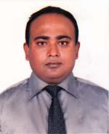 | DR. NORULLAH AL MASUD  F/Name: Mohammad Nizam Uddin  M/Name: Guljar Begum  BM & DC Reg. No: 52688  NID: 19806826019715897  Cell: 01717793643  Address: 63 Chowala, Narsingdi Sadar, Narsingdi.  Blood Group: O+
44 | Voter No  LM-4500044  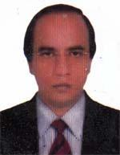 | DR. MD. MOSTAFIZUR RAHMAN  F/Name: Md. Ramjan Ali  M/Name: Most. Sahera Khatun Nesa  BM & DC Reg. No: 24572  NID: 2697683277238  Cell: 01552202055  Address: Consultant Paed, 100 Bedded District Hospital Narsingdi  Blood Group: O-
45 | Voter No  LM-4500045  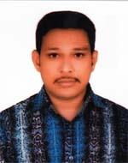 | DR. S.M QUAMRUZZAMAN  F/Name: Md. Nurujjaman  M/Name: Mrs. Sufia Khatun  BM & DC Reg. No: 36397  NID: 6826017695201  Cell: 01818451993  Address: 204, Kawria Para, Narsingdi  Blood Group: O+
46 | Voter No  LM-4500046  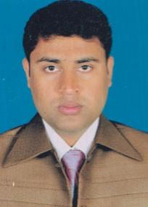 | DR. SHUKHA RANJAN DAS  F/Name: Late Anath Bandhu Das  M/Name: Suniti Rani Das  BM & DC Reg. No: 51492  NID:  Cell: 01712356938  Address: 61, KandaPara, Narsingdi.  Blood Group:

